FINAL PROJECT PROGRESS REPORT 1

CS262

NOORUL ALI (201851078), PRAKHAR BAKSHI (201851087)

ENTITY RELATIONSHIP DIAGRAM

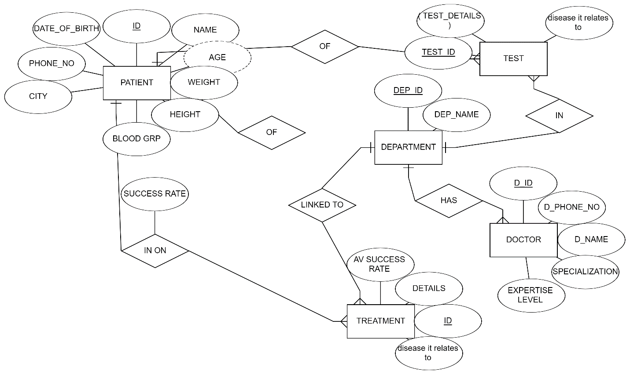

ENTITIES:

1. PATIENT: Primary entity, it deals with the end users.
2. TEST: Deals with tests related to various diseases. Contains detailed information in the form of report files. Also contains information of success rate and diseases it relates to.
3. DEPARTMENT: Tests fall within departments which are also related to treatments.
4. DOCTOR: Each department has many doctors and patients are also related to doctors. Various details of doctors are recorded for data science operations.
5. TREATMENT: Each department is associated with various treatments; doctors are also associated with them. Patients are associated to treatments and have individual success rates.

END USER EXPECTATIONS:

The end user we target are primarily hospitals. They can use this database to characterize success rates of treatments, profile diseases, relate parameters of various treatments with features of patient.

It is understood that this database will have easy access to data, based on GUI or CLI. Queries will be done in a user-friendly manner.

TIMELINE:

This project is being built in a testing time for us. The timeline of this project will fluctuate with intense hours of work followed by long periods of no progress. We request you to not ask us for progress reports because of this variable nature of our work routine.

But we assure you of a project that is capable of meeting expectations by the final deadline. This project will always be a work in progress due to its nature and the grander aims we have for it, but we will provide a good base model as our final project.